Serial and Network Interfaces

Table of Contents

UART/USART IC 3

8251 UART/USART IC 4

Universal Serial Bus 5

Variants 5

Components 6

FireWire 7

Variants 7

Digital Visual Interface 8

High-Definition Multimedia Interface 8

Isochronous Connections 8

SCSI and iSCSI 9

InfiniBand and Fibre Channel 9

Wireless Communication 10

Infra-Red 10

Radio Frequency 10

Infra-Red Data Selection 10

Bluetooth 11

IEEE 802.11 11

IEEE 802.15.4 11

In networking, we learnt about the **physical layer**. At that layer, devices were physically connected together via some mechanism which we did not go into the details of. The connections were actually made using some specific peripheral devices. These peripheral devices were connected via **interfaces**.

There are mainly two types of standards for peripheral interfaces:

* **EIA-232F** – This is where we connect the VGA cable. It is also called an RS-232 Serial Interface or a COM port.
* **Universal Serial Bus** (USB)

Other than these, we also have **FireWire**, a low cost device for digital signals, **SCSI** and **iSCSI**, which are mainly used for permanent storage and CDs and DVDs, and **InfiniBand** and **Fibre Channel**, which are for high speed connections.

## UART/USART IC

Writing a program that is compatible with different serial communication protocols is difficult and also an inefficient use of the microprocessor. This is where the **Universal Asynchronous Receiver/Transmitter** (UART) and **Universal Synchronous/Asynchronous Receiver/Transmitter** (USART) chips come in. These are **programmable chips** that receiver data from the microprocessor **parallelly** and then transmit the data to I/O devices **serially**.

### 8251 UART/USART IC

The **8251A** interface chip is packed in a 28-pin DIP. Its functions are integrated into standard PC interface chips.

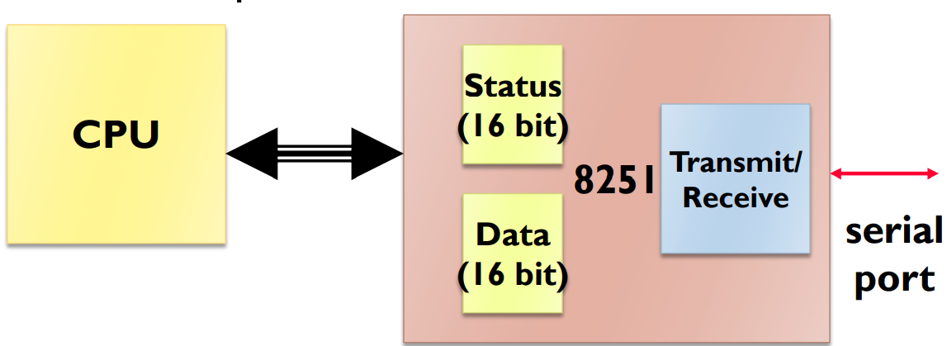

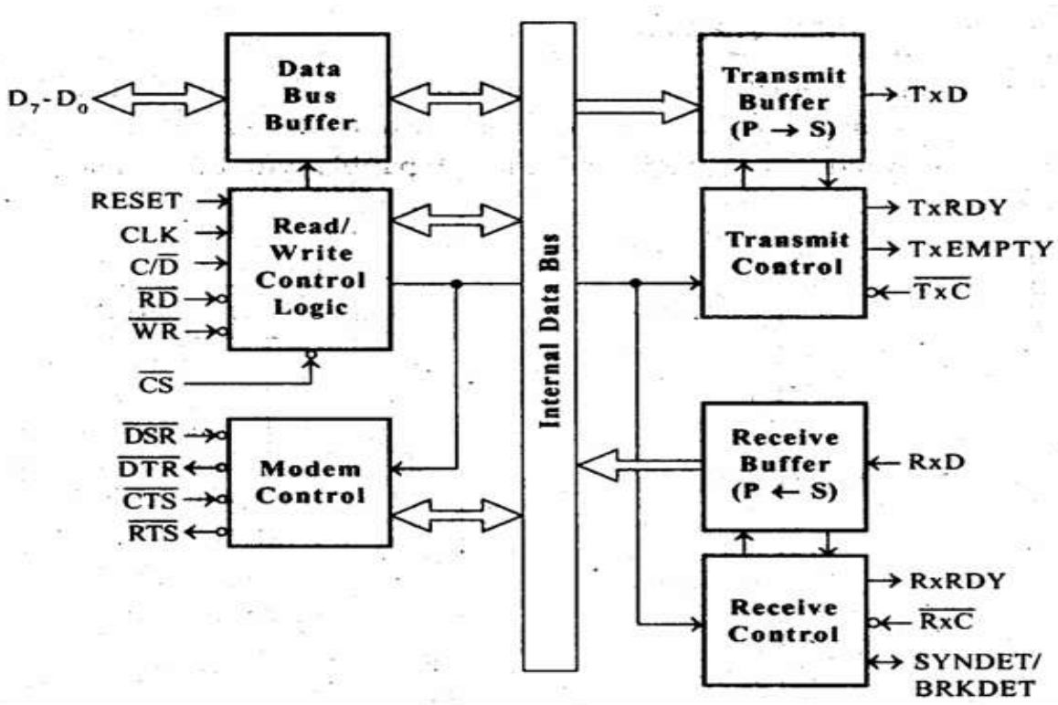

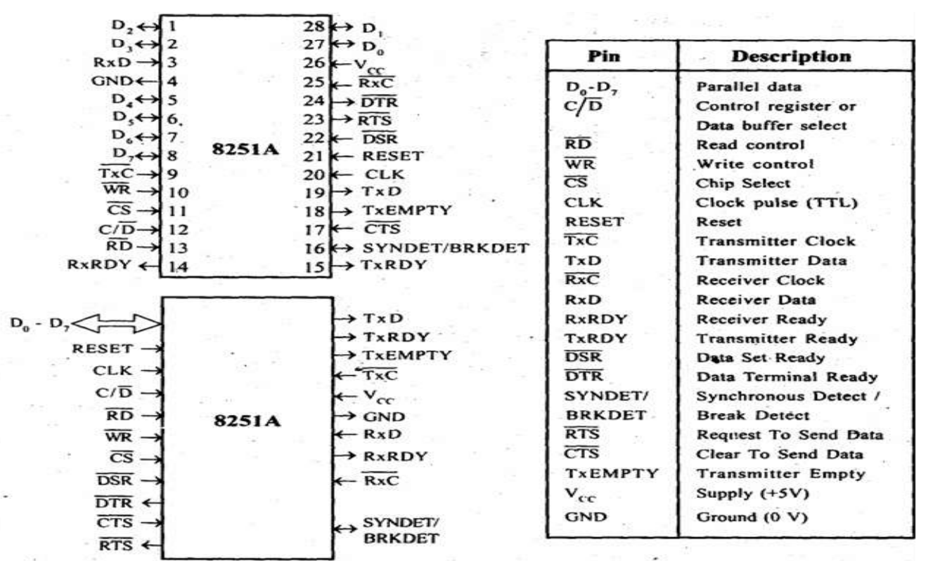

## Universal Serial Bus

USB is a newer and more powerful standard than EIA-232F. It can be used to connect a wide range of peripheral devices to PCs, including printers, scanners, keyboards, mice, etc. USB supports **hot swapping**, meaning it can be plugged and unplugged while the PC is on, and is **plug and play**, meaning no drivers need to be installed. The required drivers are actually available in the PC already, installed along with the OS. With USB, we can have up to 128 devices daisy chained together in a hub.

### Variants

There are different variants of USB. USB 1 had transfer speeds of up to 12 Mbps. USB 2 increased this to 480 Mbps and USB 3 is the latest version, with speeds up to 5 Gbps.

There are 4 types of connectors used by USB, USB A, USB B, Mini-A and Mini-B.

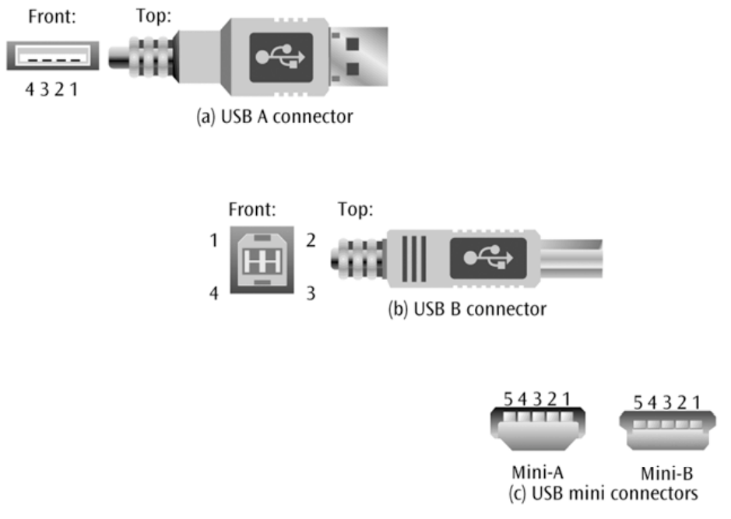

We also have a new type, USB C, which is not shown in the diagram since it is the latest connector type.

### Components

USB has a mechanical and an electrical component.

The **electrical component** defines a VBUS and a GND wire to carry a 5 volt signal, and also two D+ and D- wires to carry data and signaling information.

The **mechanical component** precisely defines the size of the four connectors and uses four wires.

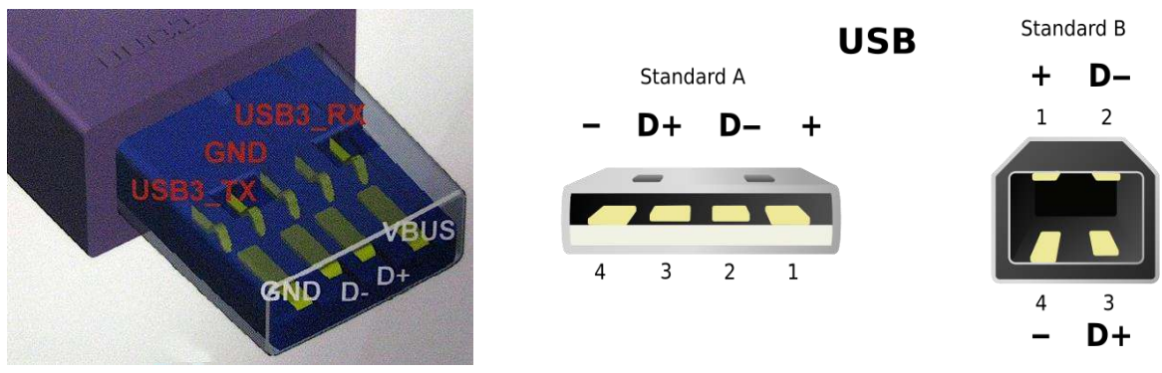

## FireWire

**FireWire** is a cheap digital interface which provides real-time connections for PCs. It allows us to send data to and from high-bandwidth digital devices, like digital camcorders, at speeds faster than USB 1 (up to 400 Mbps). Like USB, it also supports **hot swapping** and up to 63 FireWire devices can be connected at the same time. It can also provide a modest power supply to the devices.

Originally developed by Apple for their MACs, FireWire got picked up by Sony and used in camcorders and PCs. Some HDTVs also used it for years and it was also in the audio side of home theatres.

Firewire supports asynchronous connections as well as isochronous connections, which we will be looking into soon.

### Variants

Like USB, there are several variants of FireWire. FireWire 400 has transfer speeds up to 400 Mbps, FireWire 800 has transfer speeds up to 800 Mbps and IEEE 1394b has transfer speeds up to 3.2 Gbps.

## Digital Visual Interface

**Digital Visual Interface** (DVI) was created to connect computers to digital LCD monitors and projectors. It had a strong **copy protection** system called **High-Bandwidth Digital Content Protection** (HDCP), which made it a favorite in the HDTV industry.

## High-Definition Multimedia Interface

The **High-Definition Multimedia Interface** (HDMI) is the latest and best digital video and audio connection. It is used by a variety of devices including HDTVs, DVD players, Blu-Ray disc players, cable and satellite set-top boxes, Media Centre Edition PCs and gaming consoles.

## Isochronous Connections

Apart from synchronous and asynchronous connections, **isochronous connections** are a third type defined at the data-link layer specifically for **real-time applications**. Data must be delivered at just the right speed, not too fast and not too slow, thus providing data in a regular period of time. Typically, this requires resources on both ends. Both USB and FireWire support isochronous connections.

## SCSI and iSCSI

**Small Computer System Interface** (SCSI) is a technique for interfacing a computer to high-speed devices such as hard disk drives, tape drives, CDs and DVDs. It was designed to support devices of a more permanent nature. SCSI is a system interface and requires an SCSI adapter.

**Internet SCSI** (iSCSI) is the same as SCSI, except that it is meant to interface disk storage to a computer via the internet.

## InfiniBand and Fibre Channel

**InfiniBand** and **Fibre Channel** are both interfacing techniques for very high speed connections.

**InfiniBand** is a serial connection or bus that carries multiple channels of data simultaneously. This allows it to reach speeds of 2.5 Gbps and support thousands of devices via copper wire and fibre-optic cables. Essentially, this creates a network of high-speed links and switches.

**Fibre Channel** is also a high-speed network that connects a computer to multiple input and output devices. It can support up to 126 devices and has data transfer rates of up to 1 billion bits per second.

## Wireless Communication

### Infra-Red

**Infra-red** is cheap and works in line-of-sight distance. This works with a diode emitting the infra-red signal as a light and an infra-red transistor detecting the signal.

### Radio Frequency

**Radio Frequency** does not have the constraint of having to be in line of sight and can also work over longer distances. It supports **frequency hopping**, which involves constantly changing the transmission frequency.

### Infra-Red Data Selection

**Infra-Red Data Selection** (IrDA) is an international organization. The protocol is design to support transmission between two devices over a **short range**, point-to-point infra-red. It has speeds of 9.6 Kbps to 4 Mbps, and is used in notebooks, printers, PDAs, cell phones, etc.

### Bluetooth

**Bluetooth** transmits weak signals on a 2.4 to 2.48 GHz or 5GHz frequency, which is part of the ISM band. It is meant for communication over short distances, up to 10 meters, with transfer speeds of up to 1Mbps.

### IEEE 802.11

**IEEE 802.11** is the proposed standard for WLAN. It supports both Ad-Hoc and Infrastructure networks and works in the physical and MAC layers. It can reach speeds of 1 Mbps, 2 Mbps, 11 Mbps, 54 Mbps and 600Mbps in different variants and uses the 2.4 GHz to 2.4835 GHz frequency band, which is part of the unlicensed band.

### IEEE 802.15.4

**IEEE 802.15.4** is the proposed standard for WPAN. It also works in the physical and MAC layers and has a data rate of 250 Kbps. It works in the 2.4 GHz to 2.4835 GHz frequency band.